LS-DYNA Model Generator Notes

**Model Summary**

-2 types of models were created based on 2 functions in LS-DYNA: Constrained Nodal Rigid Body and Constrained Node Set

-model assumptions are identical to those from the OpenSees script

1. Constrained Nodal Rigid Body Models

-when all nodes at each floor are modeled as rigid bodies, the model seems to be too stiff

-the first figure below shows the distribution of each building’s fundamental period vs. stories above grade (can be compared against the second figure below from the paper)

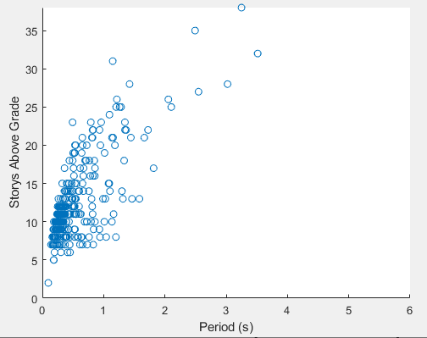

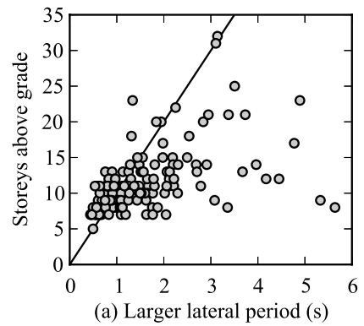

-it is possible to release translational or rotational DOF from rigid bodies

-however, the LS-DYNA manual “strongly” recommends that the releases are only used for rigid bodies that consist only of 2 nodes, especially for implicit calculations (running a model with release conditions produce error)

-adding constraints on uncoupled DOFs of mass nodes do not eliminate the error

-it is not possible to define sets of 2-node rigid bodies with releases, then link them together with more nodal rigid body commands, as nodes cannot “be subjected to multiple constraints” according to the manual

-models with rigid body constraints run successfully in eigenvalue and time history analysis with no releases

2. Constrained Node Set Models

-created models where the x and y translational DOFs are coupled for all nodes at each floor

-note that this function does not take into consideration the rotational aspect of a rigid diaphragm, since there is no z rotation coupling

-models with this type of constraint runs successfully in time history analysis

-eigenvalue analysis fails as the program appears to first constrain the free DOFs of mass nodes (Figure 1), then later says those same mass nodes are overconstrained (Figure 2), since they were automatically constrained by the program then constrained by the constrained node set function

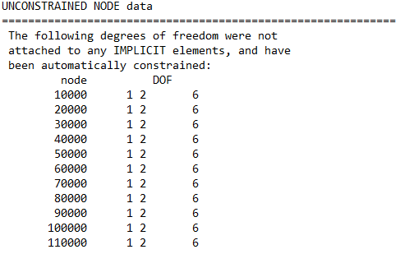

Figure 1

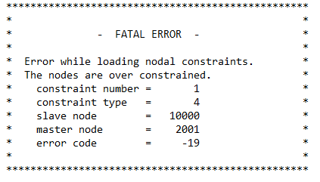

Figure 2

**Files**

-note that model assumptions from the files below may be slightly different, because:

a) model assumptions evolved over time

b) the purpose of these models was to validate whether or not certain functions in LS-DYNA achieve a specific result

c) once a function is deemed unsatisfactory, the associated script was not updated with newer assumptions

1. dyna_card_generation_eigen_node_set_apr30.m

-eigenvalue analysis with constrained node set

2. dyna_card_generation_apr29.m

-eigenvalue analysis with constrained nodal rigid body

3. dyna_card_generation_gm_node_set_apr30.m

-time history analysis with constrained node set

4. dyna_card_generation_gm_rigid_apr30.m

-time history analysis with constrained nodal rigid body

5. Earthquake Record.xlsx

-earthquake record for time history analysis

6. dyna_run_model_feb26.m

-runs eigenvalue analysis for all buildings then creates a fundamental period vs. story above grade plot